## Influx Solutions

**Influx Solutions BPO Services, Company Profile.**

**Phone:** +91 9686078809

**Email:** [info@influxsolutions.in](mailto:info@influxsolutions.in), [arun@influxsolutions.in](mailto:arun@influxsolutions.in)

**Web:** [www.influxsolutions.in](http://www.influxsolutions.in)

**Address:**

#82/152/1, Neeladri Main Road, Electronic city Phase 1, Bangalore-560100.



## Influx Solutions

* **INFLUX** provides a broad portfolio of information technology solutions andbusiness processto its clients

world wide. Our core portfolio comprises application development, business process consulting services as well

as professional staffing services in information-technology.

* We are experienced in providing high quality solutions to clients in diverse business areas.
* We are providing cost effective global support by our offshore partners across India and other countries.



**INFLUX**

* INFLUX BPO Servicesis based in Bangalore, Karnataka, India.
* INFLUX is engaged in delivering Software and BPO services to onshore and offshore clients.
* The company was founded on the core values of Transformation, Excellence, Integrity, and Trust.
* INFLUX Specializes in the delivery of integrated solutions that leverage its expertise in BPO.
* INFLUX offers its clients a unique advantage by our integrated approach in designing and

implementing customized outsourcing solutions.

* We consult our clients to understand their needs and internal processes and build solutions accordingly

and implement them while ensuring continuity in services.

* All our clients benefit from INFLUX, commitment to quality, integrated approach to outsourcing and

economical solutions.

* INFLUX, a fast growing business entity providing Data publishing, Data entry and Data conversion

services in various domains.

* Working with INFLUX is a cost-effective alternative to onshore or offshore services.
* We have access to the highest levels of skilled and educated labor.
* We see ourselves as a strategic partner rather than just a service provider.
* We engage with selected clients where we are confident of adding value to their business.

How INFLUX DIFFERS?

Our focusis on leveraging new technologies using proven and cost effective method for each client.

1. **Striving for Excellence**

In INFLUX, work doesn't stop at delivery of services. We continuously improve our processes, improve skill sets of our workforce, increase our capabilities.

#### Technology Adaptability

We believe in adapting quickly to the changing environment and see every change and challenge as an opportunity to set us apart and distinguish ourselves. We quickly adapt to technology changes and manage to work at difficult situations, meeting different needs of customers, taking on wider job scopes, and rise to the occasion.

#### Customer Focus

We are gaining essential competitive advantage through our customer-focus processes. Our processes are systematically aligned with Customer Expectations and company wide business goals. Our success rate in Customer Gaining is more than 90%.



# **BPO Services**

Influx offers customized business processing services that match international standards in terms of precision and execution. The organization has experience in processing large volumes of data required by major corporate and government organizations.

**Customer Support Service**

At INFLUX we provide our clients with state of our technical support, which includes

* Customer services
* Product Feature
* Services Support
* Troubleshooting

**Document/Form Processing:**

INFLUX Document Process Services Offers clients an end-to-end flexible package of services to manage large volumes of data and documents. Our global Process Center Specialize in Capturing, Digitizing, storing and archiving data.

* Inbound Document Processing
* Image/Data Archival

**DATA ENTRY/DATA PROCESSING**

From Image files in any format Yellow Pages and White Pages Data Capture/ Collection Receipt/Bill Data Entry Catalog, Data Entry for Mailing List/ Mailing Label.

**Digital Scanning:**

Digital scanning is a computer vision technology solution where smart devices are used to read objects, texts and perform the intended texts.

**Translation Services:**

Translation is a form of art we aim to redraw your masterpiece, not with Colors but with words, adopt a Double-Road Methodology for Proof reading.

**Data Transcription:**

Data Transcription Services included transcript data from one format to another format. Our Data Transcription Services are provided from our offshore centers in India at a far lower cost than available in other countries.

sdf

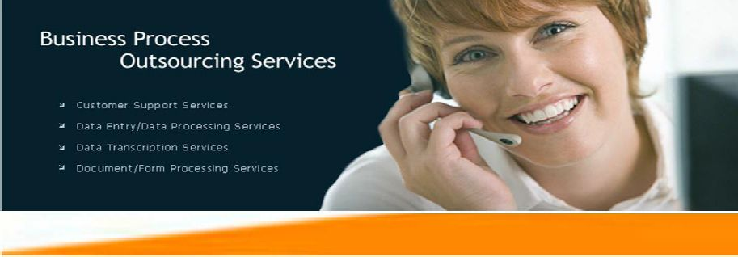

**Professional Consultancy Services:**

INFLUX Professional Consultancy Services through its Global Resource Division (GRD) helps organization source recruit and manage their most important assets – Human Resources. We have extensive experience in sourcing teams to service clients. This gives the client flexibility to rely on one source for resources and provides us the edge required to ensure that team dynamics works to the advantage of the client both in terms of quality and cost. Such models have been tried and successfully implemented by the management team in numerous occasions across the globe for clients with differing objectives and cultures.



**Our Staffing Service Models are:**

* + Temporary Staffing (Short Term)
  + Permanent Staffing (Long Term Contract)



**Application Development Services:**

Our team know exactly what to do to improve your business process and requirements of IT solutions to your Business. Regardless of industry, we offer flexible & suitable solutions to meet your service challenges. Our broad portfolio of services can help turn your business challenge into a competitive success.

**Our service portfolio comprises of**

* Custom Application Development
  + Web Applications Development
  + Application Support & Maintenance
  + Application Testing
  + Application Migration
  + Web Design & Maintenance

You need a partner who can ensure success with an approach that gives you best possible solutions, cost, speed and quality. We help you to create new business applications that capitalize on modern technologies & tools to increase your competitive advantage. INFLUX provides full life cycle applications development services with the skills, resources, technologies to develop feature-rich business applications.





**Services Offered**

Domain Details

* + Document Scanning and Indexing
  + 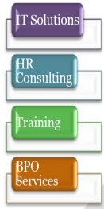Forms processing
  + Document management
  + KPO
  + Data Entry & Form filling
  + Data Conversion
  + Data Mining Process
  + Ware House Management
  + International Voice Process (US Process)
  + Domestic Inbound Voice Process



# **Our Clients**



**Our Vision & Mission**

**Mission**

To be a most preferred quality software development and resourcing partner throughout the world by providing quality services.

**Vision**

To be a successful service oriented company globally by meet or exceed our customer needs and expectations by delivering cost effective, right quality and customer oriented technology solutions on time.





**You can reach us at**

**Influx Solutions**

**Address:** #82/152/1, Neeladri Main Road, Electronic city Phase 1, Bangalore-560100.

**Phone no:** +91 9686078809

**Influx Solutions**

**Website:** [**http://www.influxsolutions.in**](http://www.nitorglobal.com/)

**E-mail**: [**info@influxsolutions.in**](mailto:info@nitorglobal.com) **Phone no:** +91 9686078809

🕾

